Centro Cultural Mexicano Paso del Norte
Cultural Program 2017
Prensa El Paso
2017
September
Photography Exhibit
Diego & Frida: Una Sonrisa a la Mitad del Camino
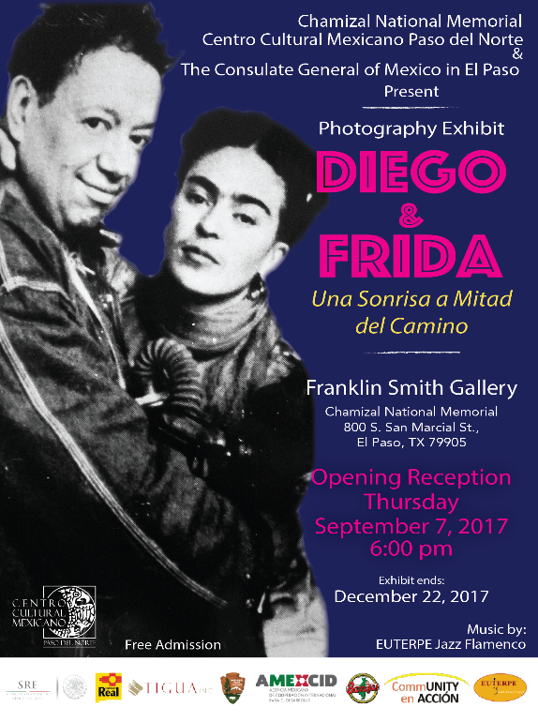 | Inauguration Date: | September 7th, 2017
 | Exhibition ends: | December 22nd, 2017
 | Time: | 6:00 pm
 | Venue: | Franklin Smith Gallery
 | Address: | 800 S. San Marcia St.,  El Paso, Texas 79912
 | Description: | Is a Photographic exhibition that displays an extensive part of the daily life of this unique couple through the lens of Guillermo Kahlo, Peter Jules, Guillermo Zamora, Nickolas Murray, Edward Weston, Manuel Álvarez Bravo and Juan Guzman among others.  The photographs reveal Frida’s pain and physical detriment during the years, Diego as a senior, and the couple’s last picture together.  The main purpose of this exhibition is to share with the audience the amazing, heartbreaking, intense intimate life of the couple.

September

Mural Dedication
“A Bridge Uniting Two Countries”
by Paloma Vianey
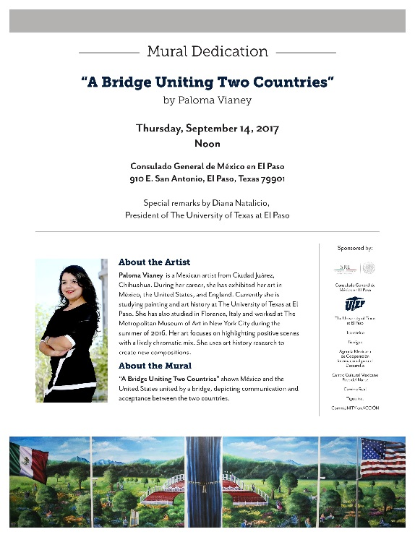 | Inauguration Date: | September 14th, 2017
 | Time: | 12:00 pm
 | Venue: | Consulate General of Mexico in El Paso
 | Address: | 910 E. San Antonio Ave., El Paso, Texas 79901
 | Inauguration remarks by: | Dr. Diana Natalicio – President of The University of Texas in El Paso
 | Description: | A Bridge Uniting Two Republics represents Mexico and the United States being unified by a bridge easing communication and acceptance between both countries. The artwork has many a strong iconographic content with the purpose of establishing a stronger union between the two countries.
 | Author: | Mexican artist from Ciudad Juárez, Chihuahua. During her career, she has held done exhibitions in Mexico, the United States, and England. Currently, studying painting and art history at UTEP.

September

¡Vivamos México!
2017
 | Date: | September 16th, 2017
 | Time: | 4:30 pm to 9:30 pm
 | Venue: | Chamizal National Memorial
 | Address: | 800 S. San Marcia St.,  El Paso, Texas 79912
 | Description: | Celebration of the 207 anniversary of the Independence of México
 | Artists: | Ballet Folklórico de Ciudad Juárez  Ballet Folklórico Quetzales  Ballet Folklórico Paso del Norte  Sobredosis del Sabor  Aponi Kai  Alacranes Musical

September

Cinco Siglos De Identidad Cultural Viva

"Camino Real De Tierra Adentro"
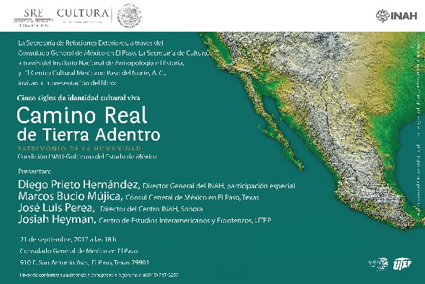 | Date: | September 24th, 2017
 | Time: | 6:00 pm
 | Venue: | Consulate General of Mexico in El Paso
 | Address: | 910 E. San Antonio Ave., El Paso, Texas 79901
 | Description: | Announcement of the result of 18 years of studies, by a team of 200 researchers within a binational project. With the objective of sensitizing the community with the heritage of the “Camino Real de Tierra Adentro”, which includes Chihuahua, Texas and New Mexico.
 | Special Guest: | Dr. Diego Prieto  Anthropologist  General Director of  National Institute of Anthropology and History of México

October

Carlos Prieto
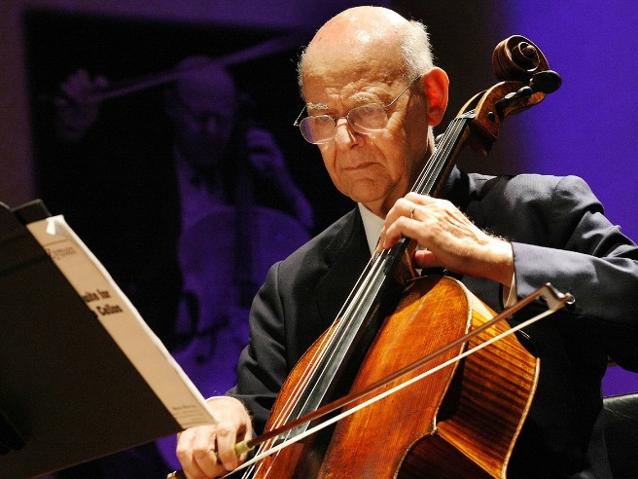 | Date: | October 7th, 2017
 | Time: | 7:00 pm
 | Venue: | Rio Grande Theatre
 | Address: | 211 North Main Street Las Cruces, NM 88001
 | Artist: | Mexican cellist and writer.  He plays a Stradivarius cello named "Piatti" after Carlo Alfredo Piatti, affectionatelly nicknamed "Chelo Prieto" by the current owner.  He is a promoter of contemporary, original classical instrument music by Latin American composers.

November

“Bonding Cultures”
Piano Concert by Romeyno Guitierrez
 | Dates: | November 4th, 2017  November 5th, 2017
 | Time: | To be Confirm
 | Venue: | Fox Fine Arts Recital Hall  Rio Grande Theatre
 | Address: | 500 W University Ave M301, El Paso, TX 79968  211 North Main Street Las Cruces, NM 88001
 | Description: | Romeyno Gutierrez will offer an imaginable classic concert, which will fuse his Raramuri roots.  He will be interpreting music of famous composers like Pachelbel, Vivaldi, Mozart, among others, and his own compositions.
 | Artist: | Romeyno Luna  Pianist and composer Tarahumara in full development, born in Retosachi in the municipality of Batopilas, Chihuahua.

November

“A Blend of Mexico”

by Jazz Quartet of Matias Carbajal

and Esperanza Azteca Ciudad Juarez Youth Orchestra
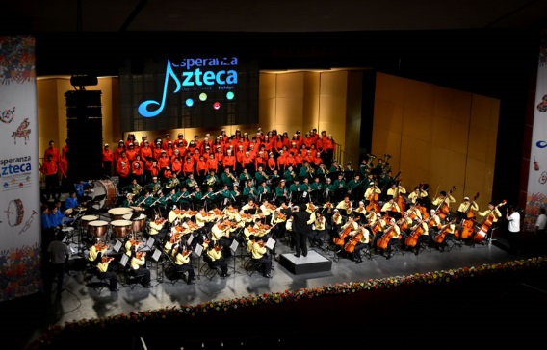 | Dates: | November 18th, 2017  November 19th, 2017
 | Time: | To be Confirm
 | Venue: | Rio Grande Theatre  Magoffin Auditorium
 | Address: | 211 North Main Street Las Cruces, NM 88001  500 W University Ave M301, El Paso, TX 79968
 | Description: | A vibrant and innovative mix that will delight the audience.  The concert was composed by Matias Carbajal that will be play by 30 musicians from the Esperanza Azteca Ciudad Juarez Youth Orchestra and the Jazz Quartet of Matias Carbajal.
 | Artists: | Esperanza Azteca Youth Orchestra involve musicians who have reached their adolescence and are anxious to continue growing and developing their skills with new challenges.

December
Binational Photography Exhibit
Photowalk
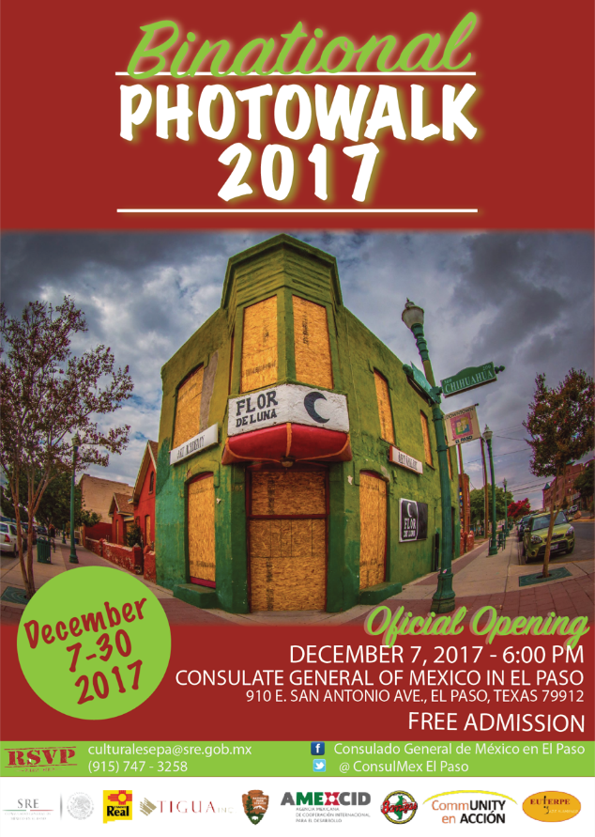 | Inauguration Date: | December 7th, 2017
 | Exhibition ends: | December 29th, 2017
 | Time: | 6:00 pm
 | Venue: | Consulate General of Mexico in El Paso
 | Address: | 910 E. San Antonio Ave., El Paso, Texas 79901
 | Description: | On October 7th, 2017, photographers from Ciudad Juarez, Chih. and El Paso, Texas, will go out to their cities downtown capturing the magic and the behavior of these cities.  The Photographic exhibition will display the best pictures of the three cities reviling the magic and uniqueness of the Border.
 | Walk organizers: | Ciudad Juarez – Alejandro Briseño  El Paso y Las Cruces – Adriana Esparza

